**DEPARTMENT OF COMPUTER SCIENCE GUJARAT UNIVERSITY, AHMEDABAD**



**PROJECT REPORT**

FOR THE PARTIAL FULLFILMENT FOR THE DEGREE OF

*POST GRADUATE DIPLOMA IN*

*COMPUTER SCIENCE & APPLICATIONS*

**(PGDCSA SEMESTER - II) YEAR: 2022-23**

HR Management System

GUIDED BY: SUBMITTED BY:

#### Ms. Jigna Satani Vikas Prajapati (20014) Parth Doshi (20005)

***Department of Computer Science***

## Gujarat University



***Certificate***

***R****oll No:* ***23*** *Seat No :****20014***

*This is to certify that Mr.* ***Vikas Shaileshbhai Prajapati*** *student of PGDCSA Semester - II has duly completed her project titled* ***HR Management System*** *for the semester ending in August 2023, towards partial fulfillment of his/her degree of Post Graduate Diploma in Computer Science & Application.*

***19/08/2023 Ms. Jigna Satani***

*Date of Submission Internal Faculty*

***Dr. Jyoti Parekh***

*Head of Department*

1

***Department of Computer Science***

## Gujarat University



***Certificate***

***R****oll No:* ***07*** *Seat No :****2005***

*This is to certify that Mr.* ***Doshi parth Devendrakumar*** *student of PGDCSA Semester - II has duly completed her project titled* ***HR Management System*** *for the semester ending in August 2023, towards partial fulfillment of his/her degree of Post Graduate Diploma in Computer Science & Application.*

***19/08/2023 Ms. Jigna Satani***

*Date of Submission Internal Faculty*

***Dr. Jyoti Parekh***

*Head of Department*

***Acknowledgement***

First and foremost, I would like to extend my sincere gratitude to the Rollwala Department of computer science, Gujarat University for their unwavering support and encouragement throughout the course of my project.

I would also like to thank DR. Jyoti Pareek Head Of Department compute science, Ahmedabad for providing me with such incredible opportunities and for all his support. I extend my warmest gratitude to Dr. Hiren Joshi, Rollwala Computer Center, Ahmedabad for providing me this platform without which none of this would have been possible.

We extend our deepest appreciation to our project supervisor, Ms. Jigna Satani, for their guidance, mentorship, and continuous encouragement throughout the project. Their expertise and constructive feedback were instrumental in shaping the direction of our work.

I would also extend my deepest appreciation to my elder sister who was also guiding me throughout my project and support me and give me continuous encouragement during the project.

I extend my sincere appreciation to my friends and family who stood by me with patience, understanding, and unwavering support. Your encouragement and belief in my abilities gave me the strength to overcome challenges and persevere.

Thank for your continues support

Sincerely,

Vikas Prajapati 19/08/2023

Parth Doshi

2

# Abstract

A Human Resource Management System (HRMS) or Human Resource Information System (HRIS) is a comprehensive software solution designed to streamline and automate various HR processes within an organization. It serves as a centralized repository for storing and managing employee-related data, facilitating efficient HR operations and decision-making.

The HR management system aims to digitize traditional HR tasks, reduce paperwork, improve data accuracy, enhance employee engagement, and promote organizational efficiency. It catersto the needs of HR professionals, managers, and employees, providing them with tool sand functionalities to handle their respective tasks effectively.

Advantages of an HR Management System:

* + **Increased Efficiency:** HRMS automates manual tasks, saving time and effort for HR professionals, allowing them to focus on more strategic initiatives.
  + **Data Accuracy:** Centralized data storage reduces the risk of errors and discrepancies in employee information.
  + **Improved Employee Engagement:** Self-service features empower employees, giving them more control over their HR-related activities.
  + **Enhanced Decision-making:** Access to HR analytics enables data-driven decision-making for better workforce planning.
  + **Cost Savings:** Streamlining processes and reducing paperwork can lead to cost savings in the long run.
  + **Compliance and Security:** HRMS helps maintain compliance with employment laws and regulations, while data security measures protect sensitive employee information.
  + **Scalability:** The system can adapt to the changing needs of a growing organization.
* In conclusion, an HR management system is an indispensable tool for modern businesses.seeking to optimize their HR processes, improve employee experiences, and drive.organizational success. It allows HR professionals to become more strategic and agile,ultimately contributing to the overall efficiency and effectiveness of the company.

3

# Index

Gujarat University 1

1. INTRODUCTION 5
   1. Purpose 5
   2. Objective 5
   3. Aim 5
   4. Scope 5

Software Requirement Specification (SRS) for Online Auction System 8

1. Introduction 8
   1. Purpose 8
   2. Scope 8
2. System Overview For Employee 8
   1. User Authentication and Registration 8
   2. My Profile 8
   3. Fill Attendance 9
   4. View Attendance 9
   5. Leave Application 9
   6. Track Leave 9
3. System Overview For HR 9
   1. User Registration and Authentication 9
   2. My Profile 9
   3. Add Employee 9
   4. Add Department 9
   5. Approve Attendance 9
   6. Approve Leave 9
4. Non-Functional Requirements 9
   1. Security 9
   2. Performance 10
   3. User-Friendly Interface 10
   4. Compatibility 10
5. Test cases
   1. Leave Management 10
   2. Attendance Tracking: 10
   3. Department Management 10
6. Conclusion 10
7. Schedule and Resource Feasibility 12
   1. Project Timeline 12
   2. Resource Allocation 13

Existing System Features & Limitations for the Online Auction System 14

Features 14

1. User Registration and Authentication 14
2. Auction Listings 14
3. Bidding Process 14
4. Auction Management 14
5. User Dashboards 14

System Analysis & Design 15

Screenshots 24

Deployment Scenarios for the Online Auction System 38

1. Cloud-Based Deployment 38
2. On-Premises Deployment 38
3. Hybrid Deployment 39

Security Features 40

Future Enhancement 42

Bibliography 43

5

* INTRODUCTION

# About the Project

In the epoch of the internet most of the HR work are done via the internet. The company over the internet manage the business & employees to manage the huge number of employees, and with smaller cost than business physically. The most common type of business which has popularity in the now is HR Management System.In this system HR can manage various Employee, Attendance, Leave, Department. HR and Employee login to system. They can manage and view Different functionalities.

HR Management System is delighted to introduce our revolutionary HR Management System, designed to streamline, and optimize every aspect of your organization's human resource functions. Our cutting-edge software is built to empower HR professionals, executives, and employees, making their lives easier and enhancing overall productivity.

* 1. Purpose
     + The main objective of the project is to develop a website that facilitates the data storage, data manage and its retrieval for the HR management system.
  2. Objective
     + To design employee friendly HR Management System in India.
     + To authenticate employee account during registration.
  3. Aim
     + To provide a simple and easy way to manage employee in a company.
  4. Scope
     + Financial Accounting and Bookkeeping
     + Inventory Management
     + Customer Relationship Management (CRM)
     + Project Management

6

* **Software Requirement Specification (SRS) for HR Management System**

1. Introduction

HR Management System is delighted to introduce our revolutionary HR Management System, designed to streamline, and optimize every aspect of your organization's human resource functions. Our cutting-edge software is built to empower HR professionals, executives, and employees, making their lives easier and enhancing overall productivity.

* 1. Purpose

The main Purpose of the project is to develop a website that facilitates the data storage, data manage and its retrieval for the HR management system.

* 1. Scope
* Financial Accounting and Bookkeeping
* Inventory Management
* Customer Relationship Management (CRM)
* Project Management

1. System Overview For Employee

The HR Management System will consist of the following key components:

* 1. User Authentication and Registration
* HR Login :- Add Employee in company & set role.
* Employee Login:- Employee.
  1. My Profile
     + Employee & HR can view Profile & also update Profile details.
     + Employee view information like his profile, fill attendance, view attendance, leave application and also track leave.

7

* 1. Fill Attendance

1. Employee can fill attendance into their Account.
   1. View Attendance
2. Employee can view his/her attendance into their Account.
   1. Leave Application
3. Employee can view his/her attendance into their Account.
   1. Track Leave
4. Employee can track his/her leave into their Account.
5. System Overview For HR
   1. User Registration and Authentication
      * Users can create accounts by providing essential details.
      * User authentication will be implemented with secure password encryption.
   2. My Profile
      * Employee & HR can view Profile & also update Profile details.
      * HR view information like his profile, Approve attendance, view employee, Add department, view department, leave approve application.
   3. Add Employee
      * HR can add employee into their company & also remove employee.
   4. Add Department
      * HR can add employee into their company & also remove department.
   5. Approve Attendance
      * HR Approve attendance on their employee in his company.
   6. Approve Leave
      * HR Approve leave on their employee in his company.

8

1. Non-Functional Requirements
   1. Security
      1. User data will be encrypted and securely stored.
      2. Secure authentication mechanisms will be implemented to prevent unauthorized access.
   2. Performance

3.4.1 The system shall support a high number of concurrent users without compromising response time.

* 1. User-Friendly Interface

4.1.3 The user interface will be intuitive and user-friendly, ensuring easy navigation and interaction.

* 1. Compatibility

4.4.1 The system shall be compatible with popular web browsers and devices.

1. Test Cases Leave Management:
2. **Apply for Leave:**
   * Input: Employee ID, Leave type, Start date, End date, Reason
   * Expected Output: Leave request is submitted successfully.
3. View Leave Balance:
   * Input: Employee ID
   * Expected Output: Display remaining leave balance for each leave type.
4. Approve/Reject Leave Request:
   * Input: Manager ID, Leave request ID, Action (Approve/Reject), Comment
   * Expected Output: Leave request status is updated accordingly.
5. Check Leave History:
   * Input: Employee ID
   * Expected Output: Display a list of previously approved and rejected leave requests.

9

Attendance Tracking:

1. **Mark Attendance (Manual):**
   * Input: Employee ID, Date, Time In, Time Out
   * Expected Output: Attendance record is successfully stored in the system.
2. Mark Attendance (Automated):
   * Input: Employee ID, Date
   * Expected Output: System automatically records the time in and time out based on predefined work hours.
3. View Daily Attendance:
   * Input: Employee ID, Date
   * Expected Output: Display attendance details (Time In, Time Out) for the specified date.
4. View Monthly Attendance Summary:
   * Input: Employee ID, Month, Year
   * Expected Output: Show a summary of attendance for the selected month including total work hours, late arrivals, and early departures.

Department Management:

1. **Create Department:**
   * Input: Department name, Department head ID
   * Expected Output: Department is successfully created with the assigned head.
2. View Department Details:
   * Input: Department ID
   * Expected Output: Display department information including name, head, and employee list.
3. Assign Employee to Department:
   * Input: Employee ID, Department ID
   * Expected Output: Employee is successfully assigned to the specified department.
4. Update Department Head:
   * Input: Department ID, New Department head ID
   * Expected Output: Department head is updated successfully.

10

5 Conclusion

This Software Requirement Specification (SRS) provides a comprehensive outline of the features, functionalities, and constraints of the HR Management System. By adhering to these requirements, the development team aims to create a robust, secure, and user- friendly HR Management System that meets the needs and expectations of both HR & Employee.



𝑆𝑦𝑠𝑡𝑒𝑚 𝐴𝑛𝑎𝑙𝑦𝑠𝑖𝑠 𝐴𝑛𝑑 𝐷𝑒𝑠𝑖𝑔𝑛



**1 Use Case Diagram**

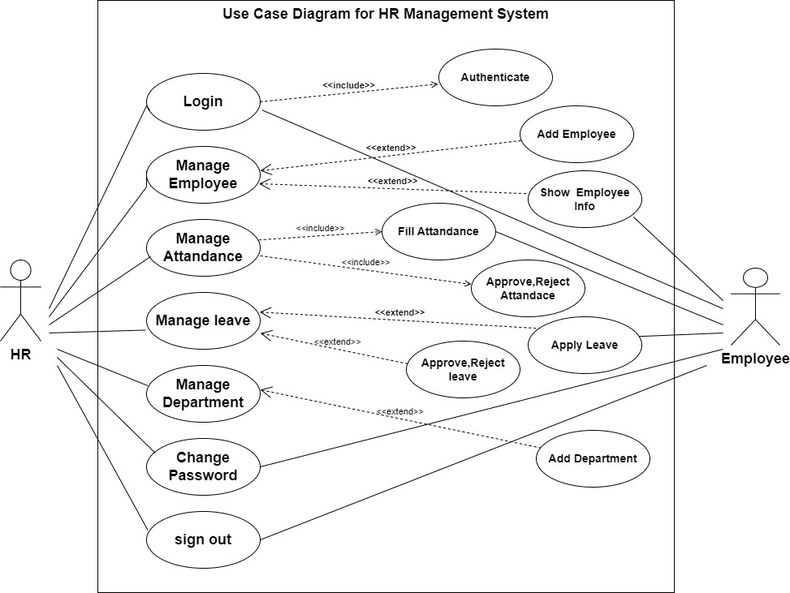



2. Class Diagram

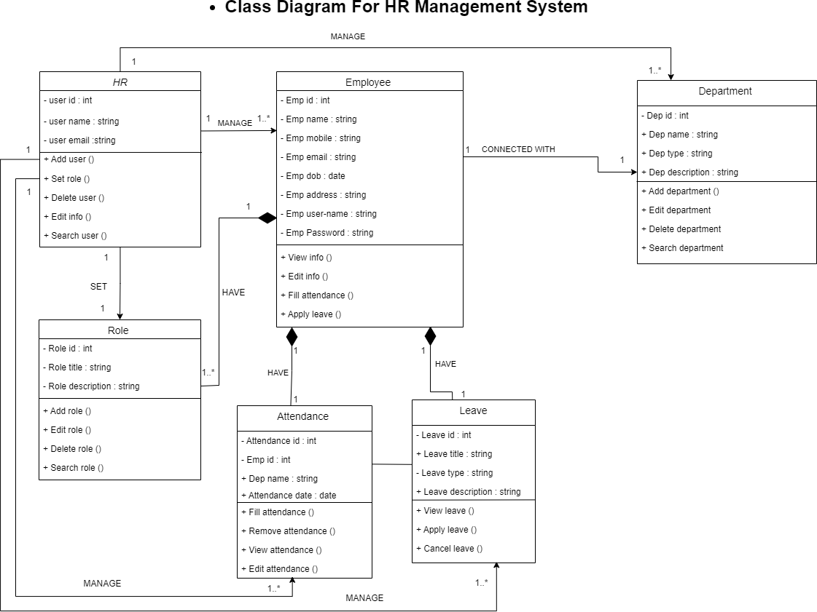



3. Sequence Diagram

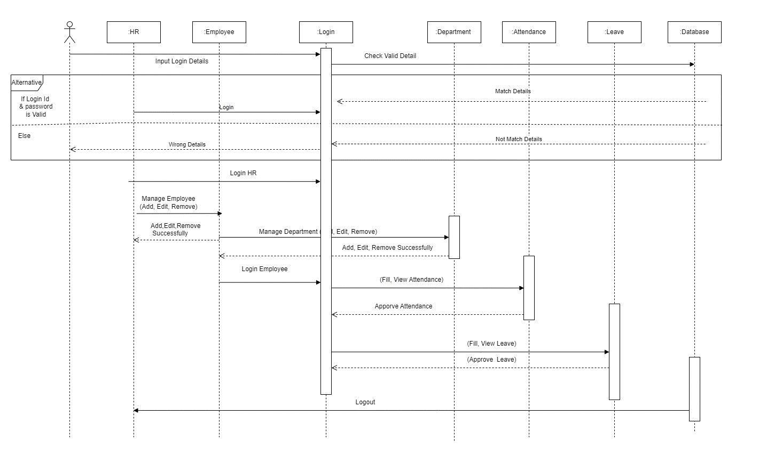



4. Activity Diagram For HR

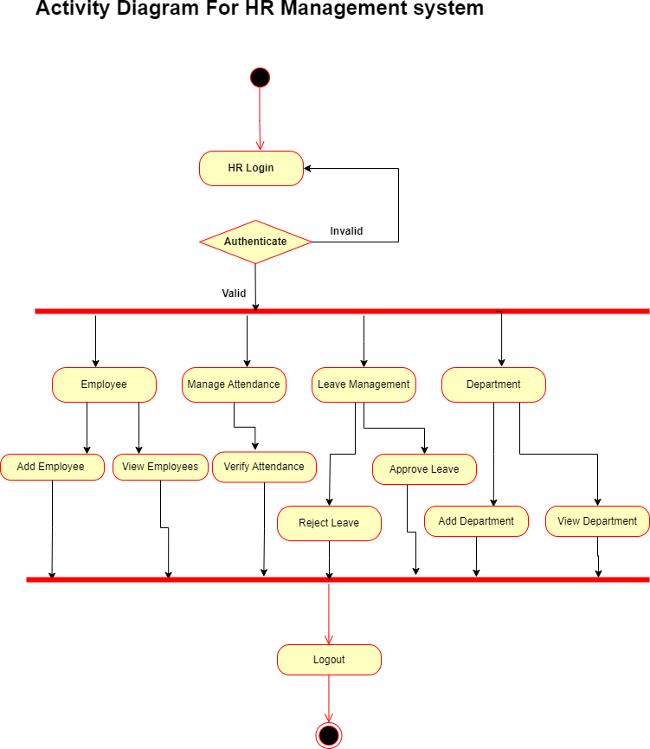



Activity Diagram For Employee

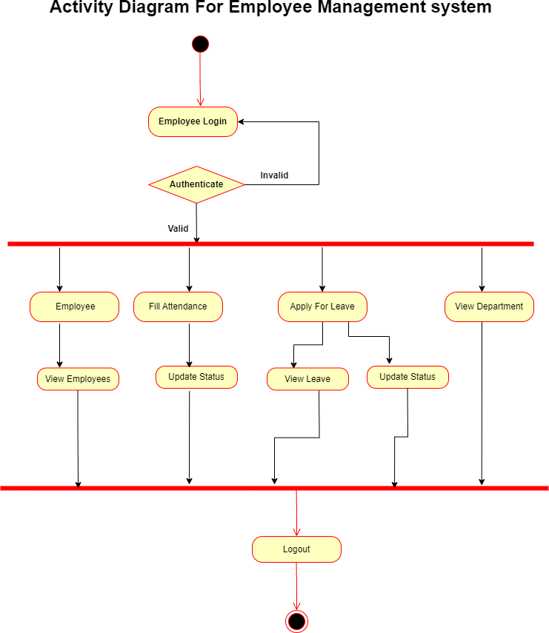

Data Dictionary

Table Name: Employee

Table purpose: To store the details of Employee

|  |  |  |  |  |
| --- | --- | --- | --- | --- |
| **Field name** | **Data type** | **Size** | **Constrains** | **Purpose** |
| e_id | Integer | 5 | Primary key | To uniquely identified Employee |
| User | varchar | 20 | Foreign key | To show User of Employee |
| emp_code | Varchar | 20 | Not null | To identify Employee  Through code |
| email | Varchar | 20 | Not null | To Store email address of  employees |
| mobile_number | varchar | 13 | Not null | To Store mobile number of Employees |
| date_of_birth | Date | - | Not null | To Store date of birth employee |
| employee_address | Varchar | 200 | Default null | To Store address of employees |
| city_id | Integer | 5 | Foreign key | To store the employee city |
| state_id | Integer | 5 | Foreign key | To store the employee state |
| aadhar_number | varchar | 12 | Default null, Unique | To store the employee Aadhar number |
| pan_number | varchar | 10 | Default null, Unique | To store the employee pan |
| dep_id | Integer | 5 | Foreign key | To store the employee Department |
| designation_id | Integer | 5 | Foreign key | To store the employee designation |
| date_of_joining | Date | - | Not null | store the date of joining |
| employee_employeement  _type | varchar | 20 | Not null | Full-time, Part-time Trainee, Probation,  Commission |

Table name: Attendance

Table purpose: to store the details about Attendance

|  |  |  |  |  |
| --- | --- | --- | --- | --- |
| Field name | Data type | Size | Constrains | Purpose |
| att_id | Integer | 5 | Primary key | To uniquely identified attendance id |
| emp_id | Integer | 5 | Foreign key | To Store the id of Employee |
| att_date | date | - | Not null | store the date of attendance |
| in_time | time | - | - | To store the time of employee Enter |
| out_time | time | - | - | To store the time of employee exit |

Table name: Leave type

Table purpose: to store the details about Leave type

|  |  |  |  |  |
| --- | --- | --- | --- | --- |
| Field name | Data type | Size | Constrains | Purpose |
| Id | Integer | 5 | Primary key | To uniquely  identify Leave type |
| name | Varchar | 30 | Not null | Sick leave, Paid leave,  Marriage Leave, Maternity leave Paternity leave |

Table name: Leave

Table purpose: to store the details about Leave

|  |  |  |  |  |
| --- | --- | --- | --- | --- |
| Field name | Data type | Size | Constrains | Purpose |
| leave_id | Integer | 5 | Primary key | To uniquely identified leave id |
| leavetype_id | Integer | 5 | Foreign key | To Store the id of leave type |
| emp_id | Integer | 5 | Foreign key | To Store the id of employee |
| From | date | - | Default null | store the date of leave start date |
| To | date | - | Default null | store the date of leave end date |
| num_of_days | Float | 15 | Default 0 | To store the total Number of leave days |
| description | Varchar | 200 | Default null | To store description about  leave |

Table name: Department

Table purpose: to store the details about Department

|  |  |  |  |  |
| --- | --- | --- | --- | --- |
| Field name | Data type | Size | Constrains | Purpose |
| Id | Integer | 5 | Primary key | To uniquely  identified Department id |
| Name | varchar | 50 | Not null | To store the department name of  employee |

Table name: Designation

Table purpose: to store the details about Designation

|  |  |  |  |  |
| --- | --- | --- | --- | --- |
| Field name | Data type | Size | Constrains | Purpose |
| Id | Integer | 5 | Primary key | To uniquely identified Designation id |
| Name | varchar | 50 | Not null | To store the Designation name of  employee |

Table name: City

Table purpose: to store the details about City

|  |  |  |  |  |
| --- | --- | --- | --- | --- |
| Field name | Data type | Size | Constrains | Purpose |
| Id | Integer | 5 | Primary key | To uniquely identified City id |
| name | varchar | 50 | Not null | To store the City name of employee |

Table name: State

Table purpose: to store the details about State

|  |  |  |  |  |
| --- | --- | --- | --- | --- |
| Field name | Data type | Size | Constrains | Purpose |
| Id | Integer | 5 | Primary key | To uniquely identified State id |
| name | varchar | 50 | Not null | To store the State name of employee |

Screenshots

##### System Implementation

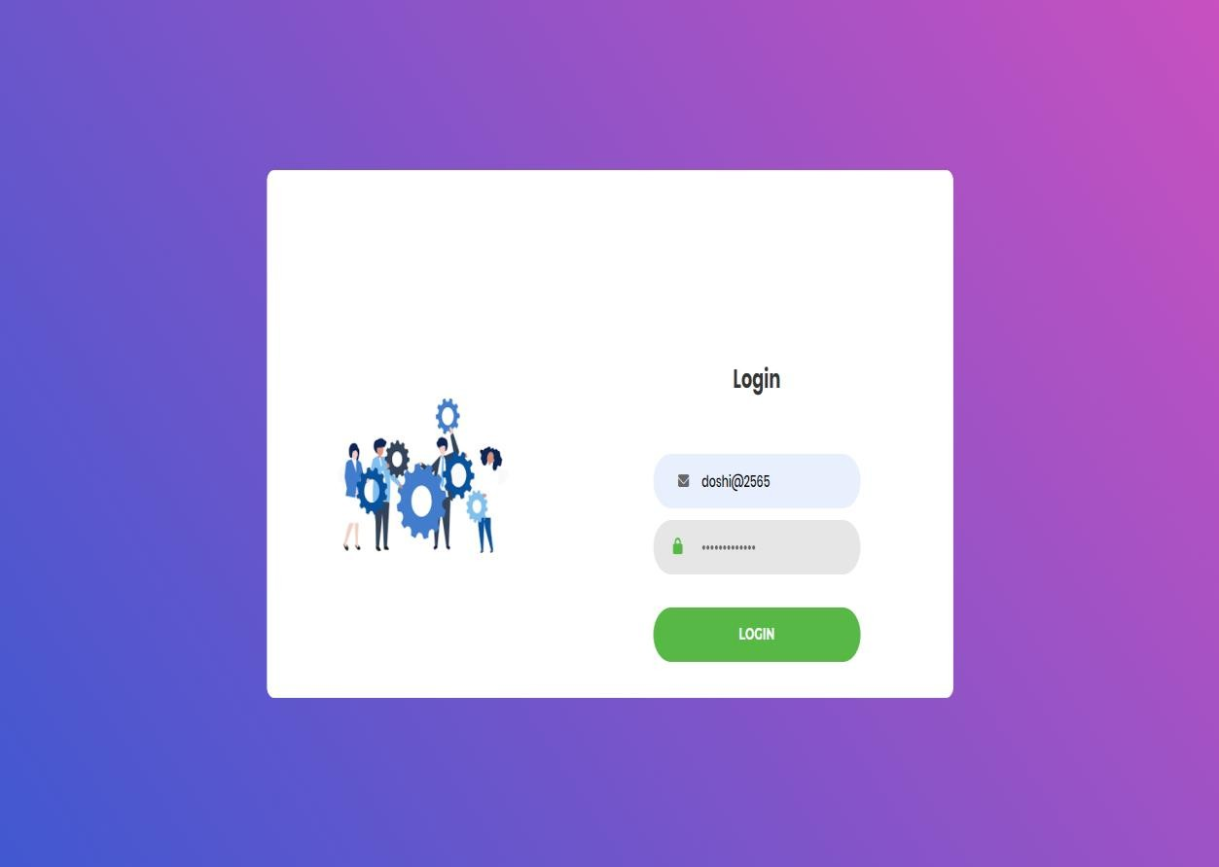

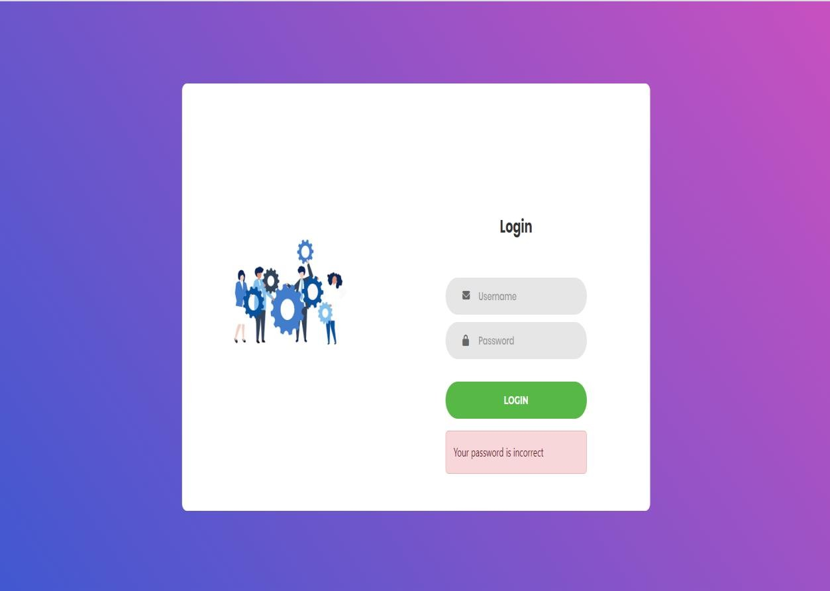

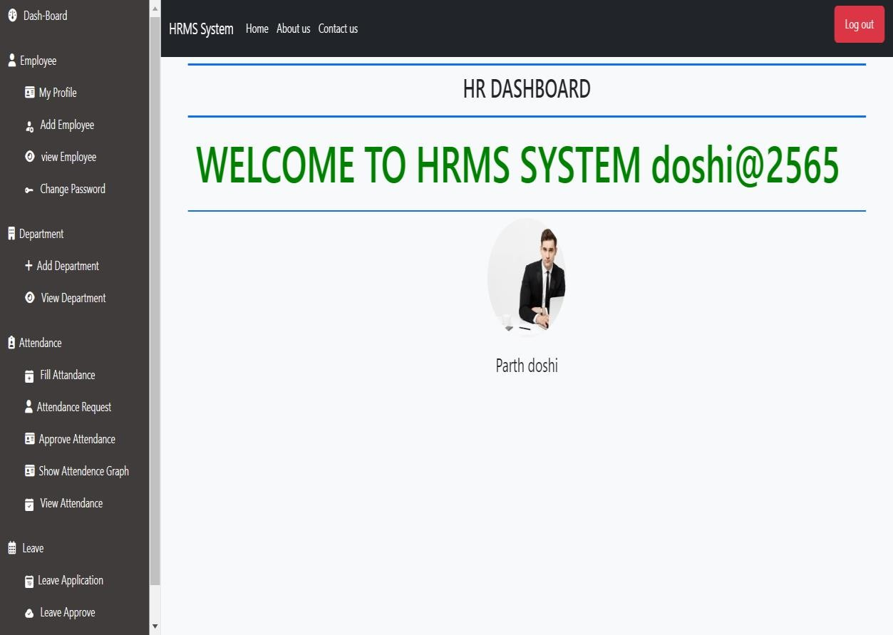

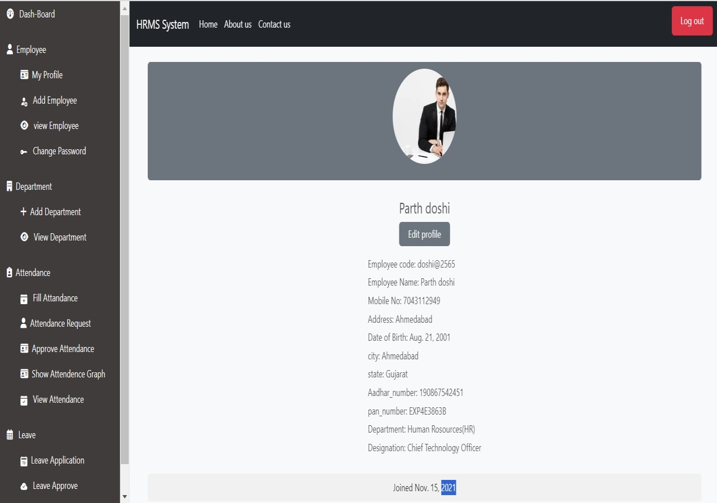

* HR is Add Employee

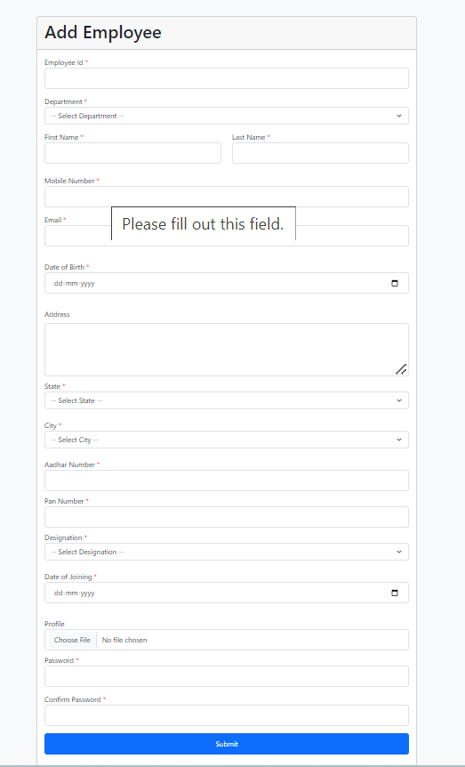

* HR view All Employees

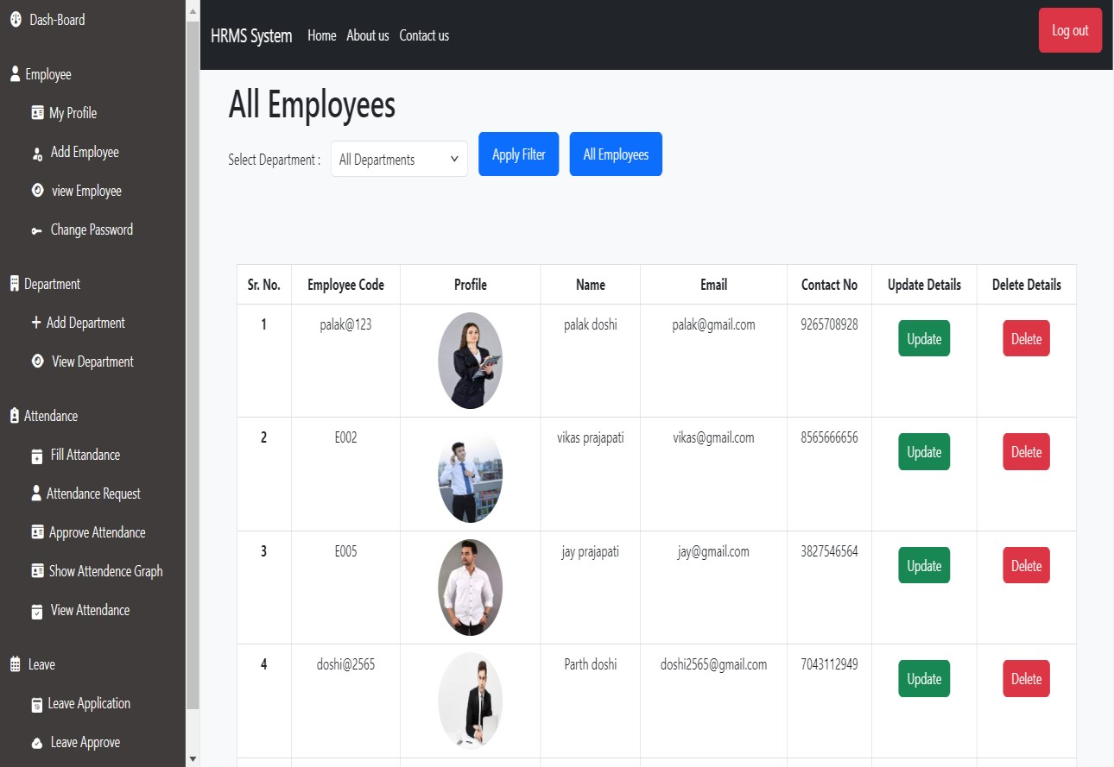

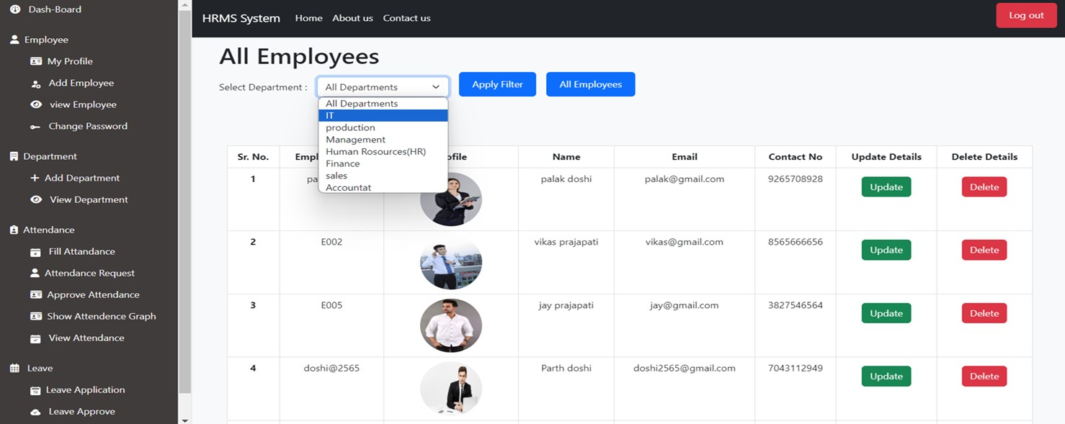

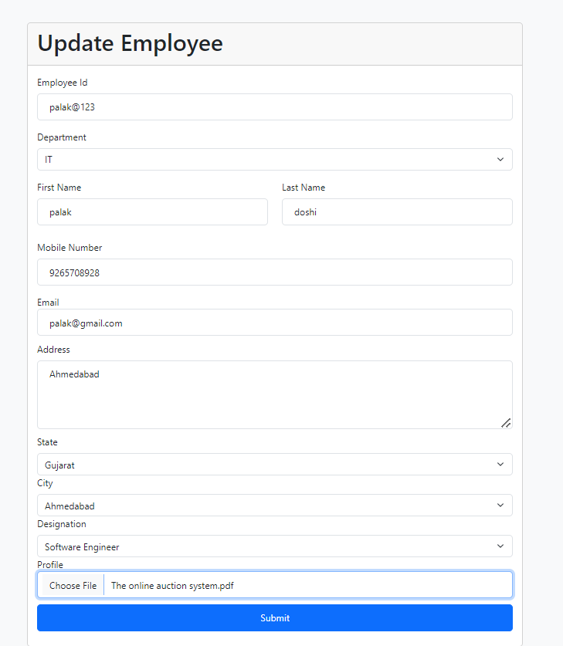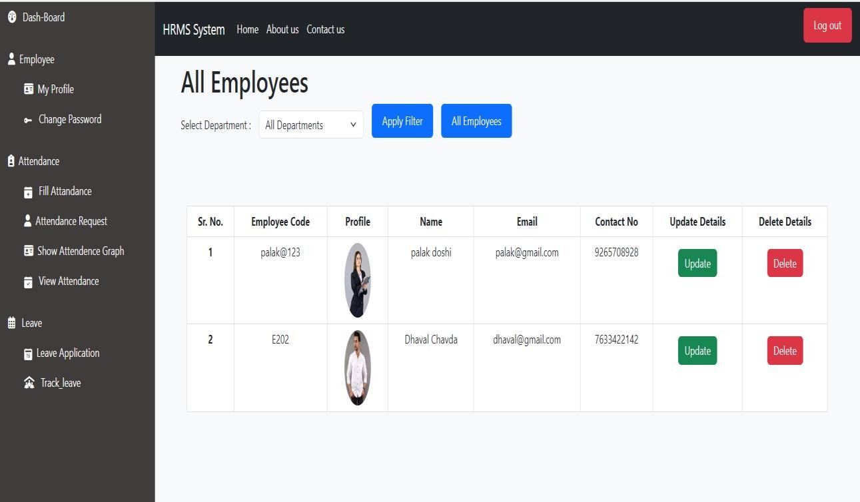

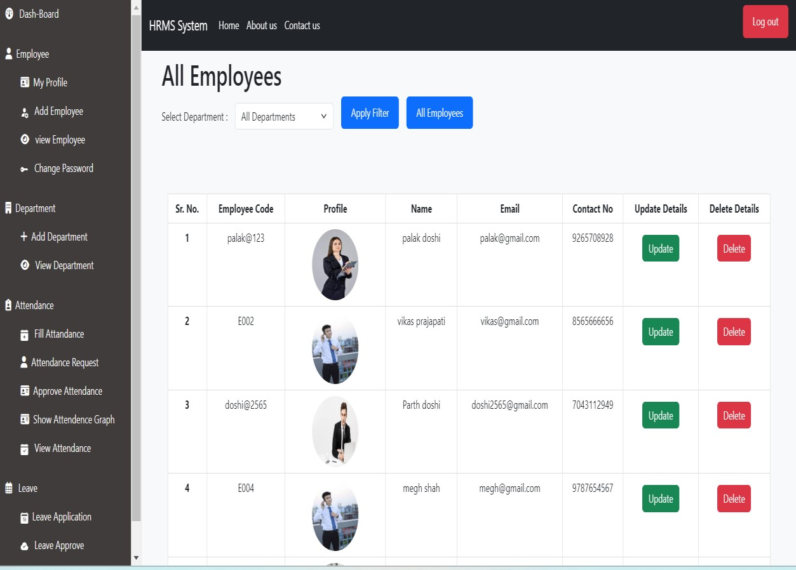

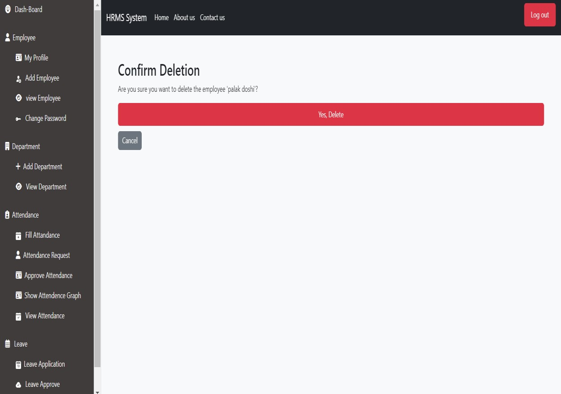

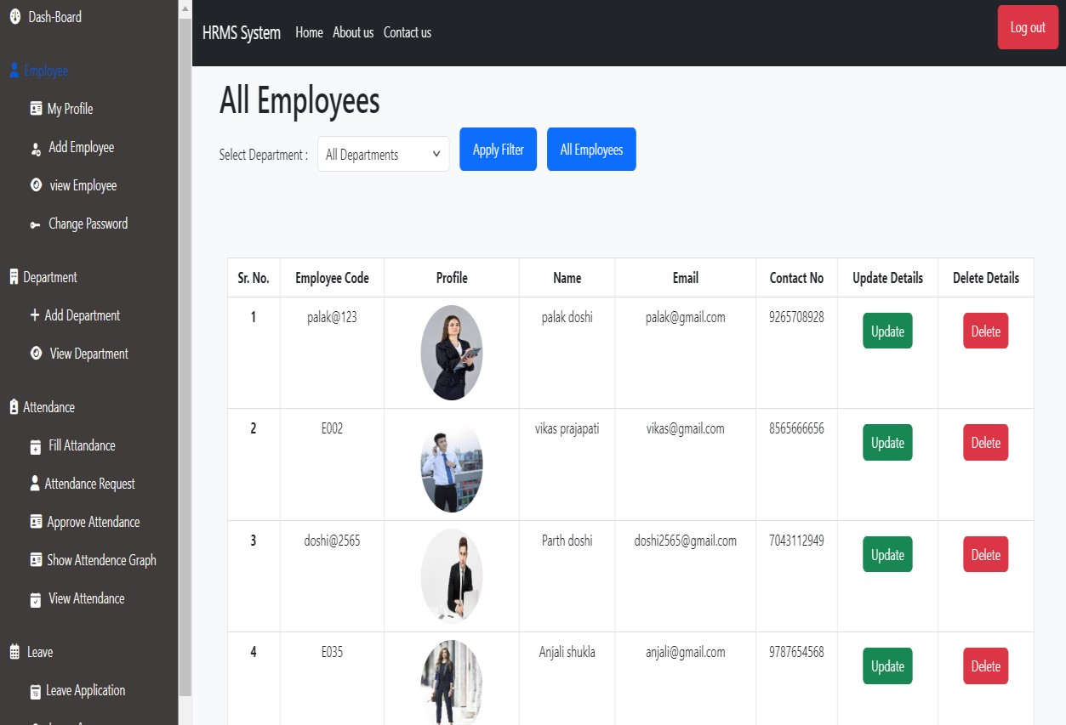

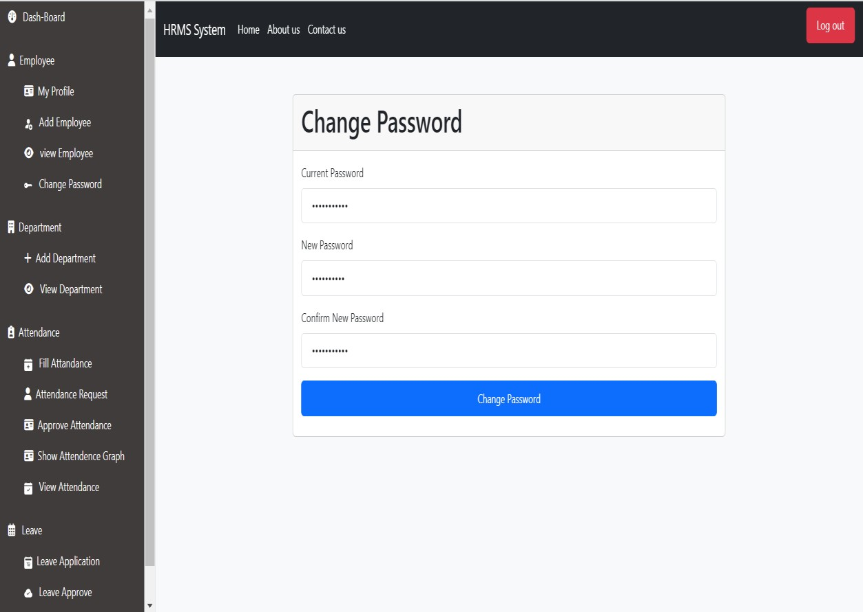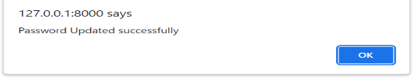

* HR Add and view Department

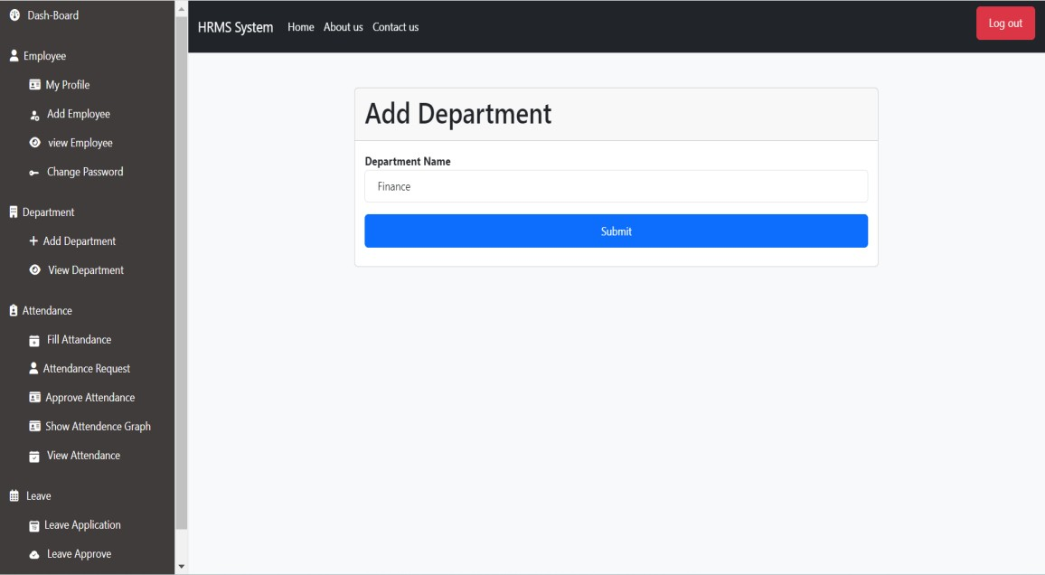

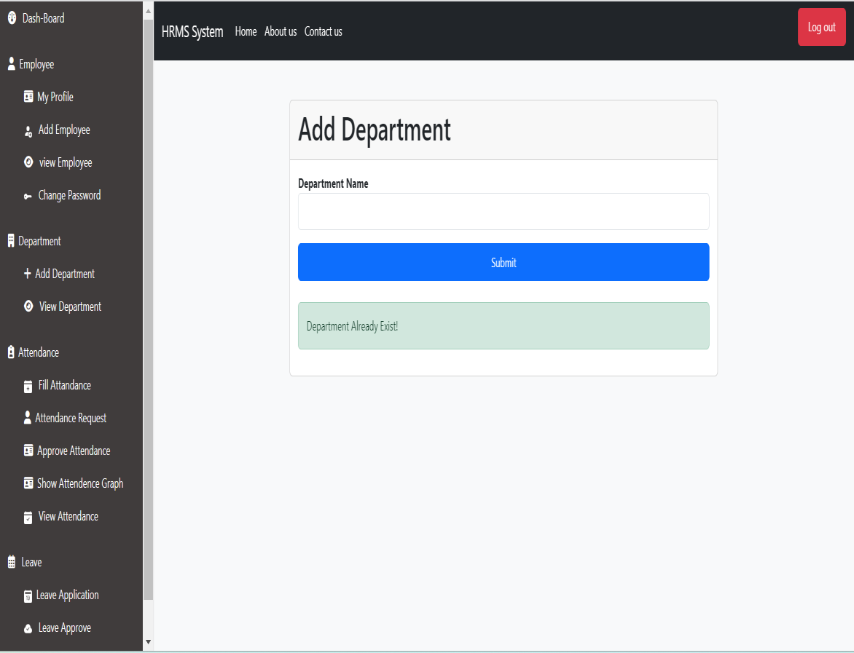

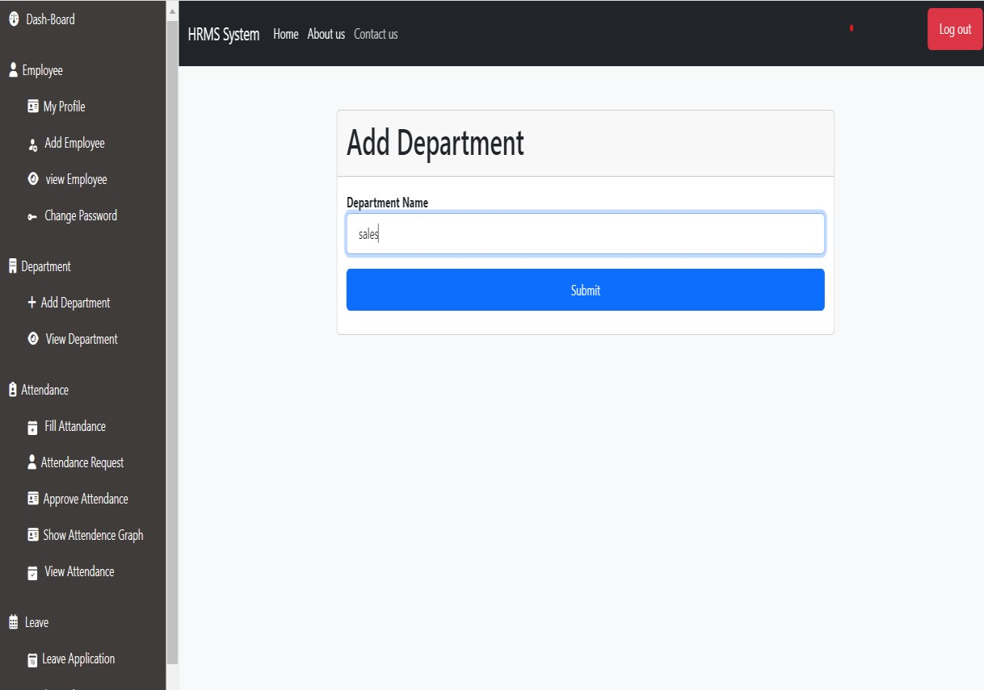

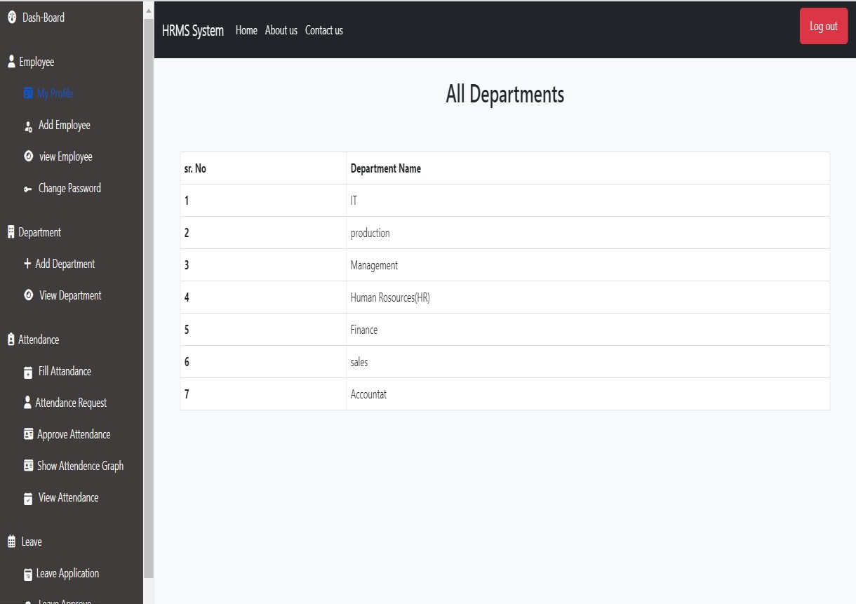

* Employee Fill Attendance

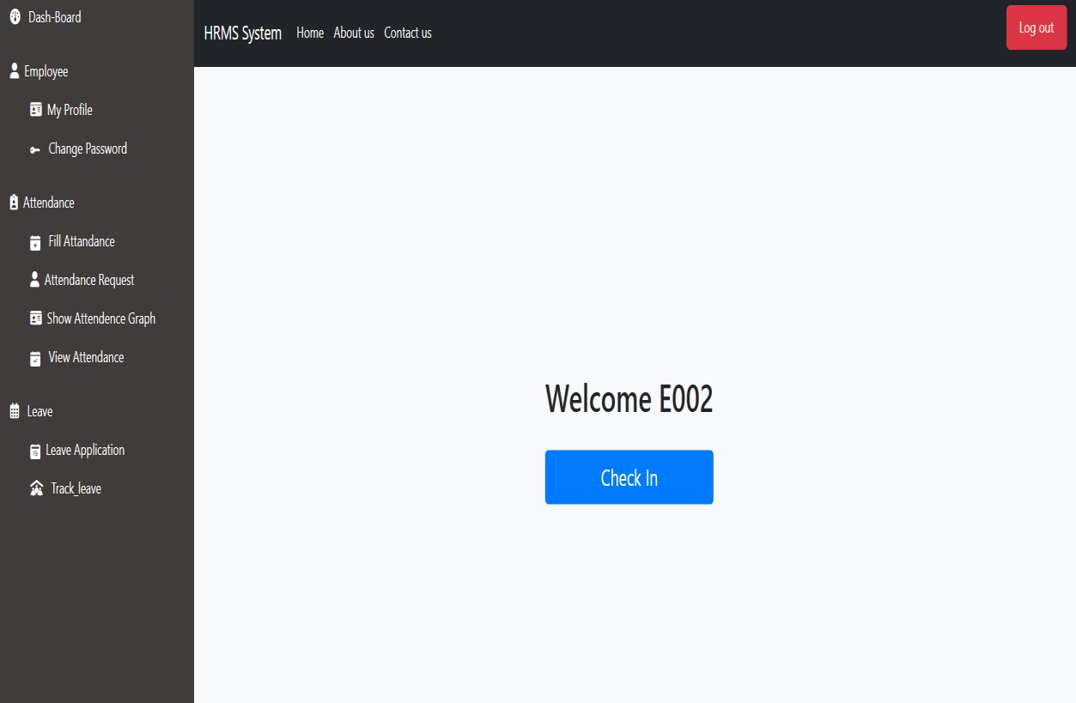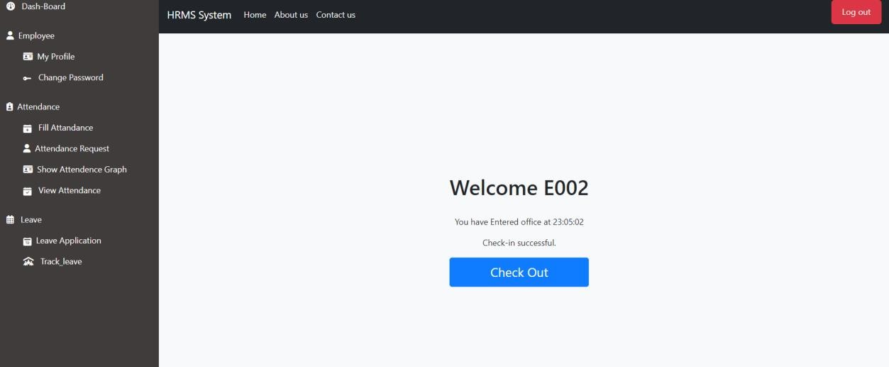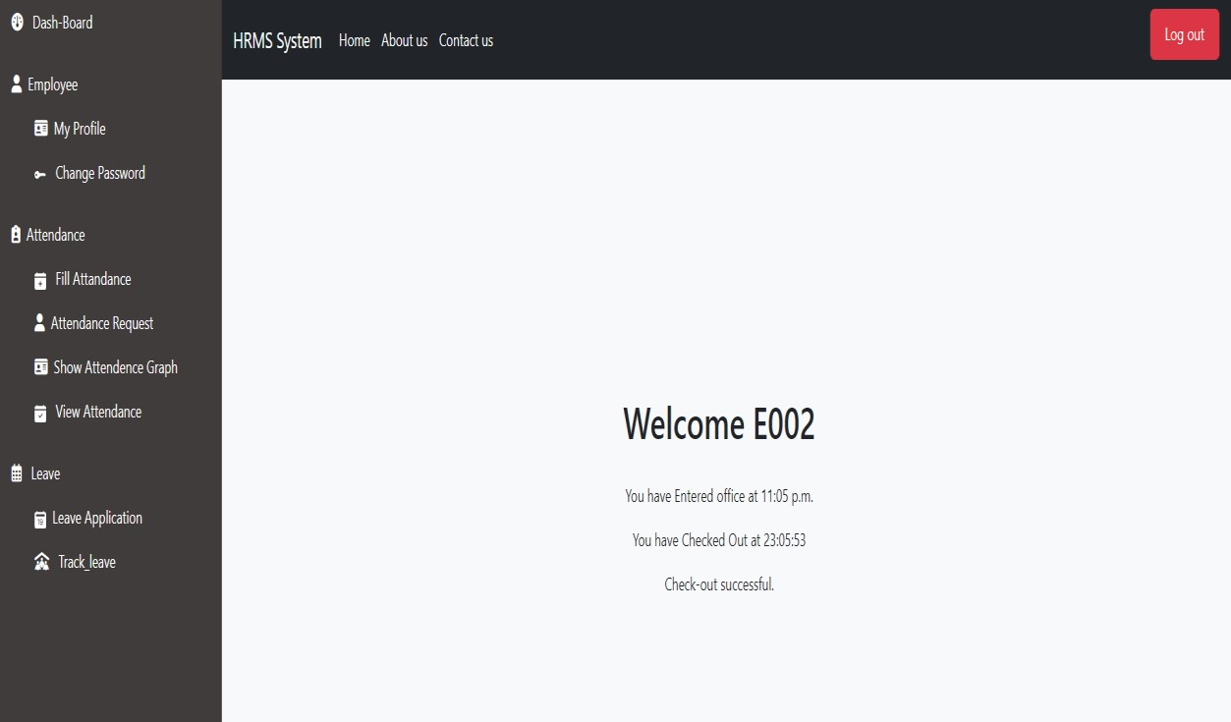

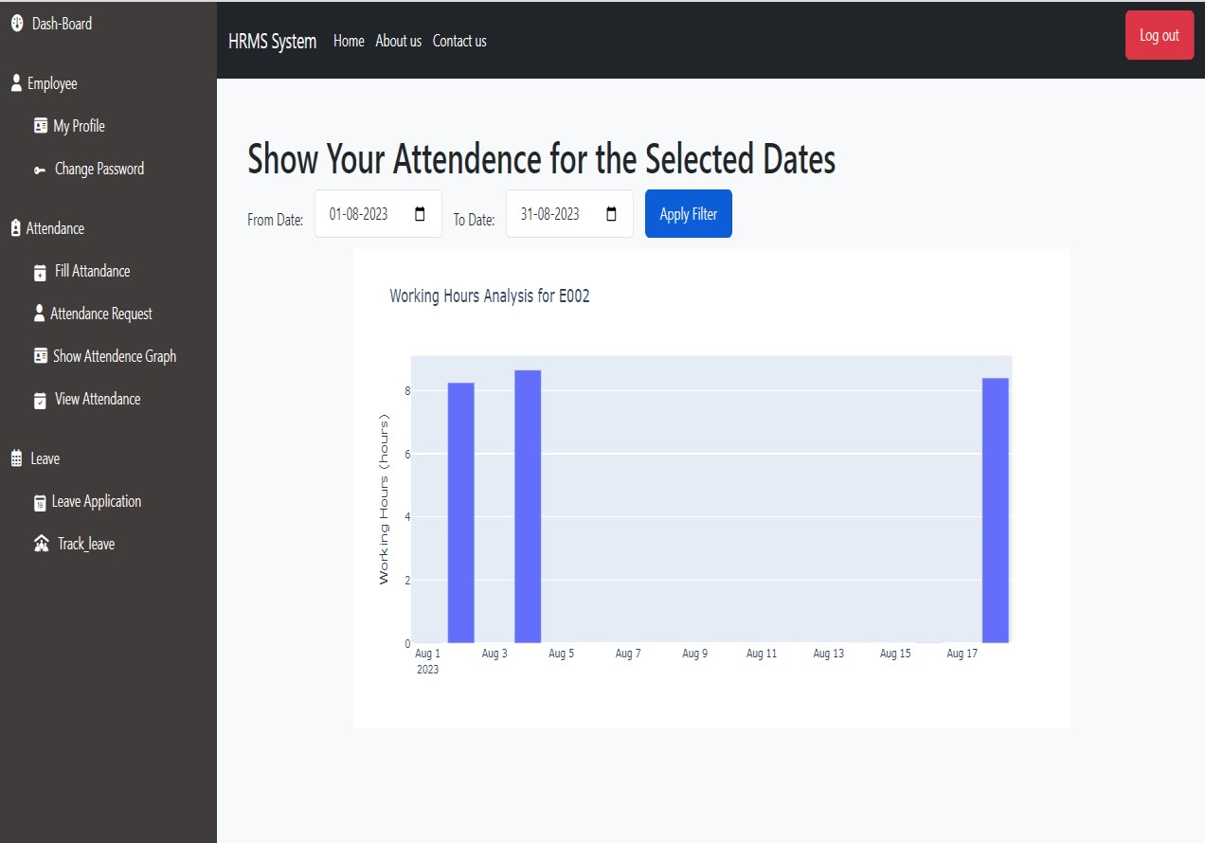

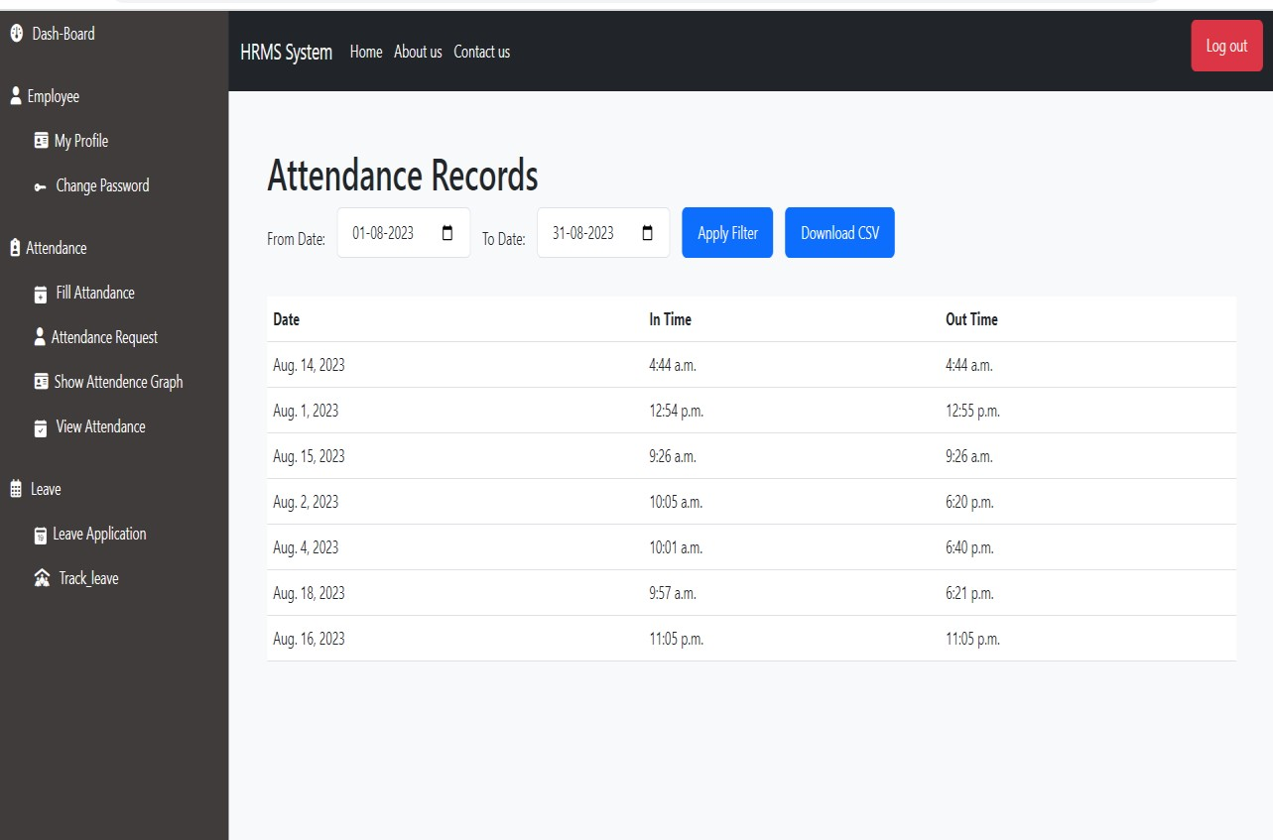

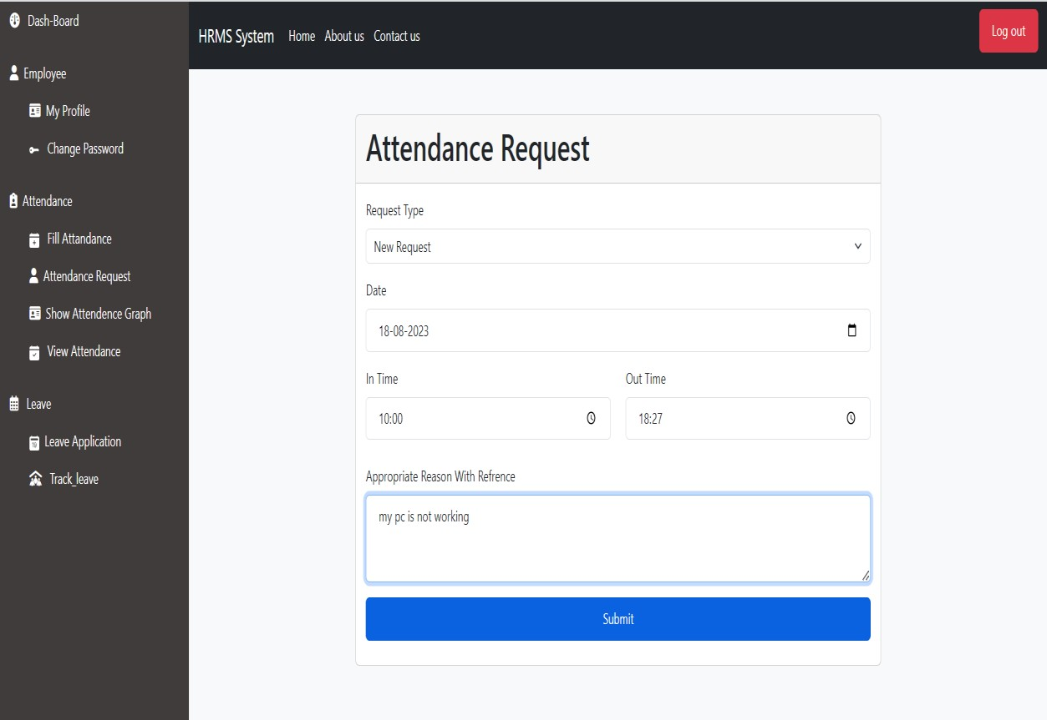

* HR Approve or Reject Request and if Approve and Reject status Update

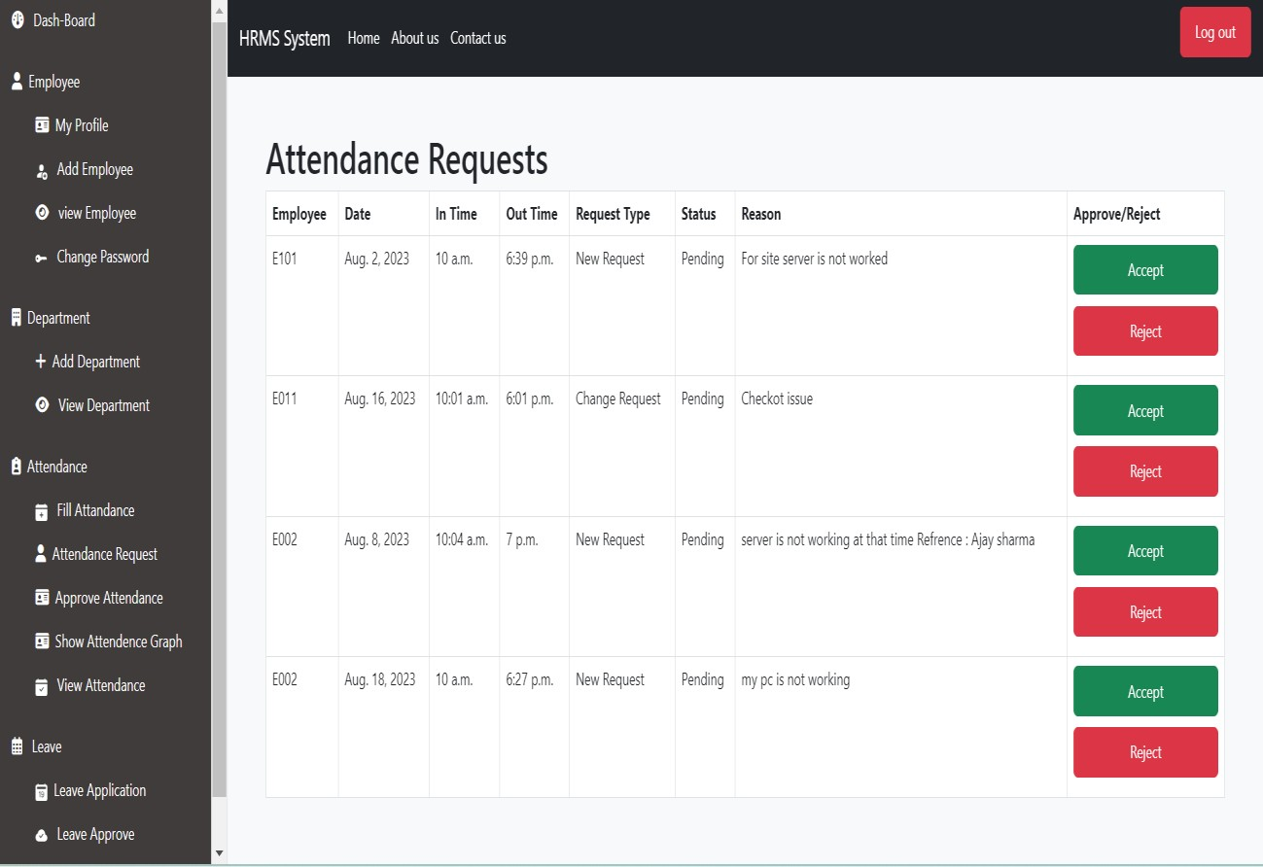

* HR is Accept Request Employee View in Records

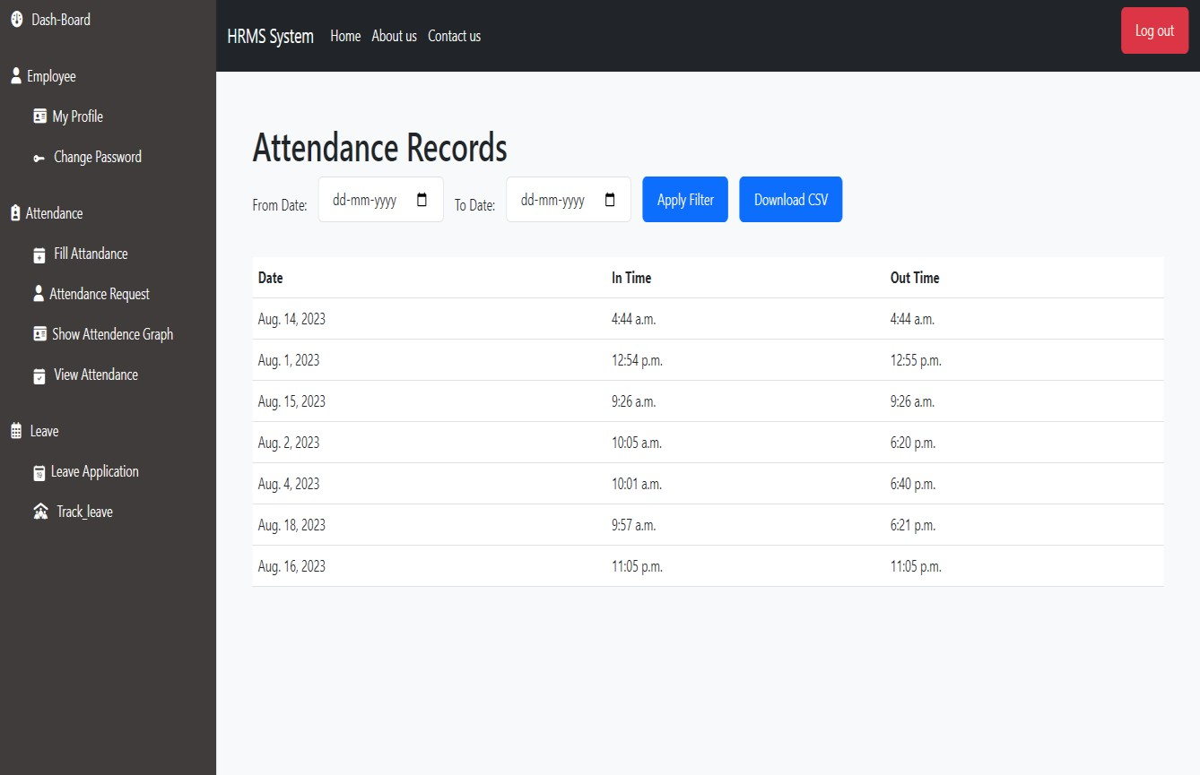

* Employee can Apply for Leave

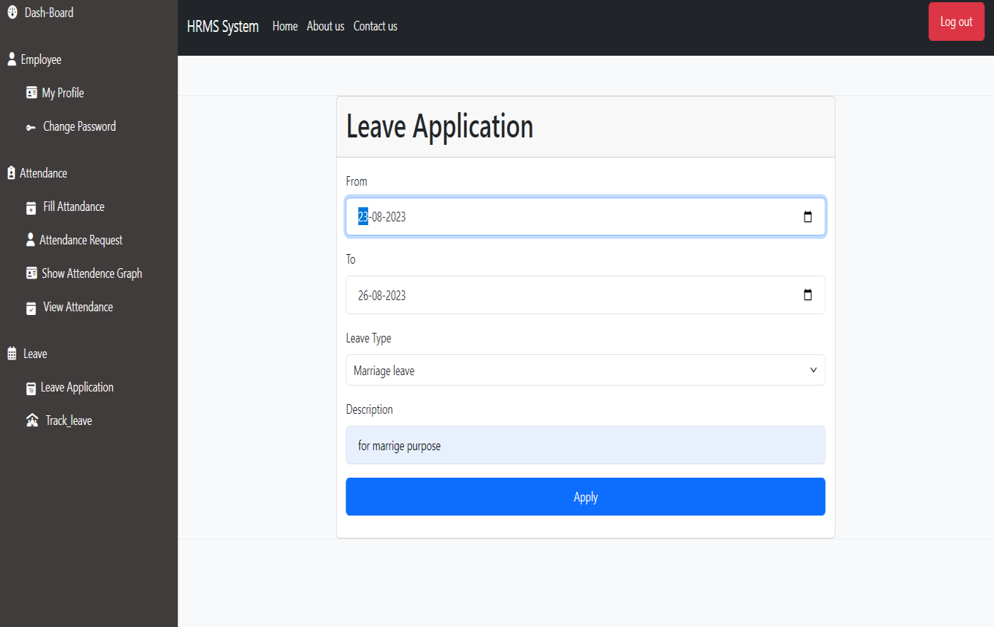

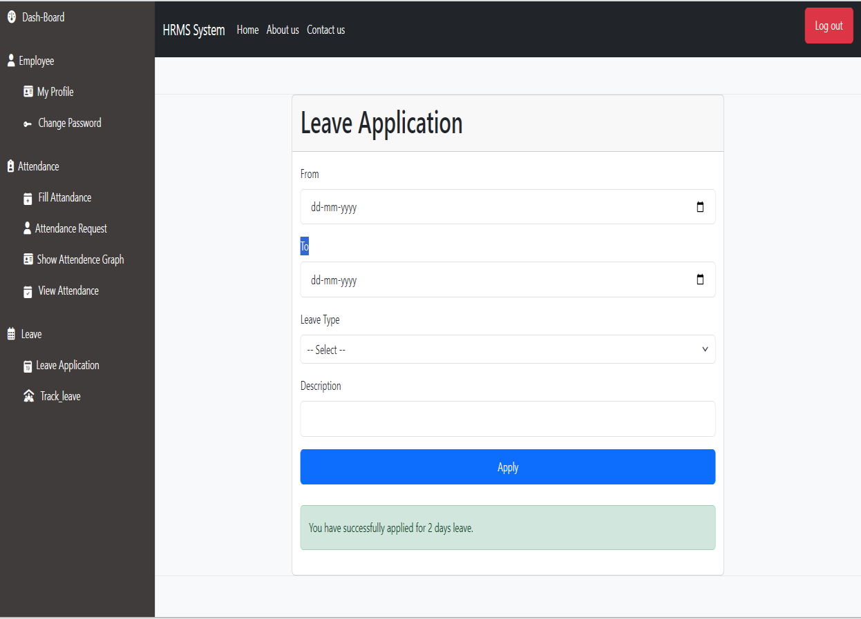

* Employee Track Leave Accept, Reject or Pending
* Employee cancel Leave Request

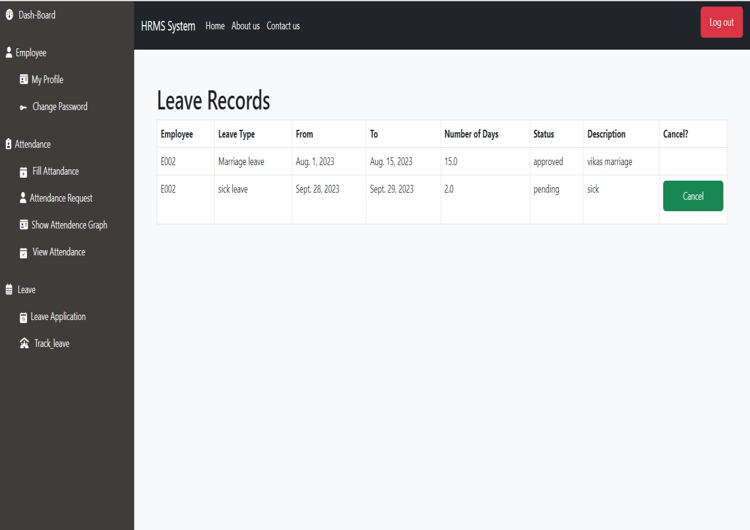

* HR Approve and Reject Attendance

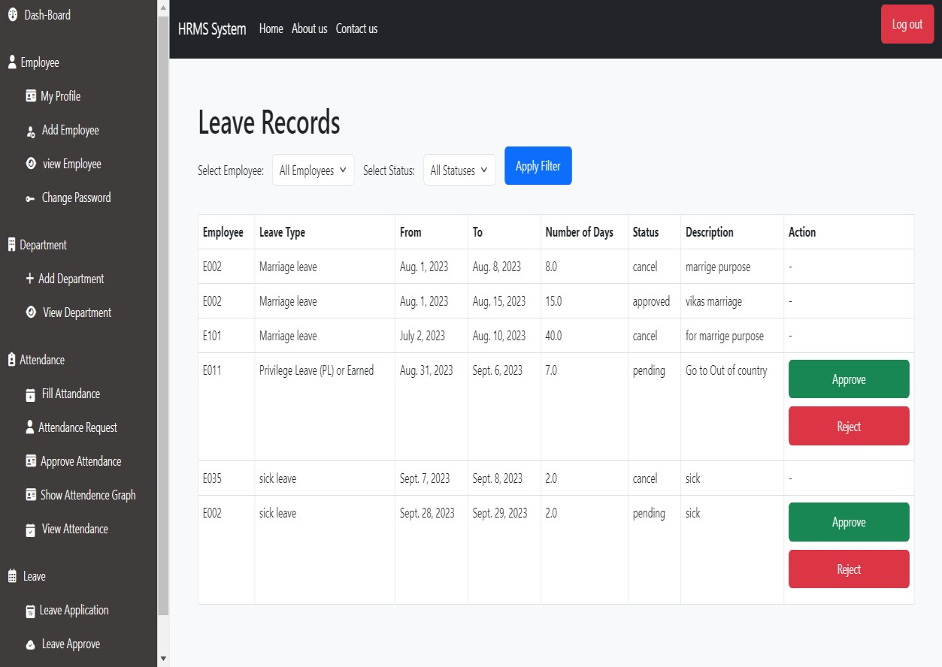

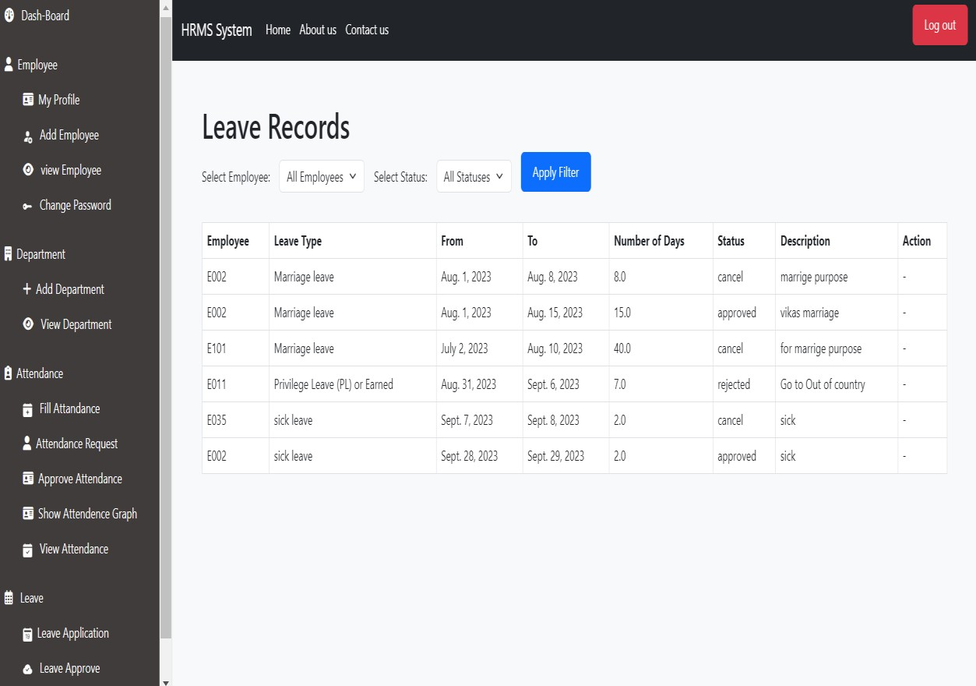

HR Filter Approve ,Reject and pending Leaves

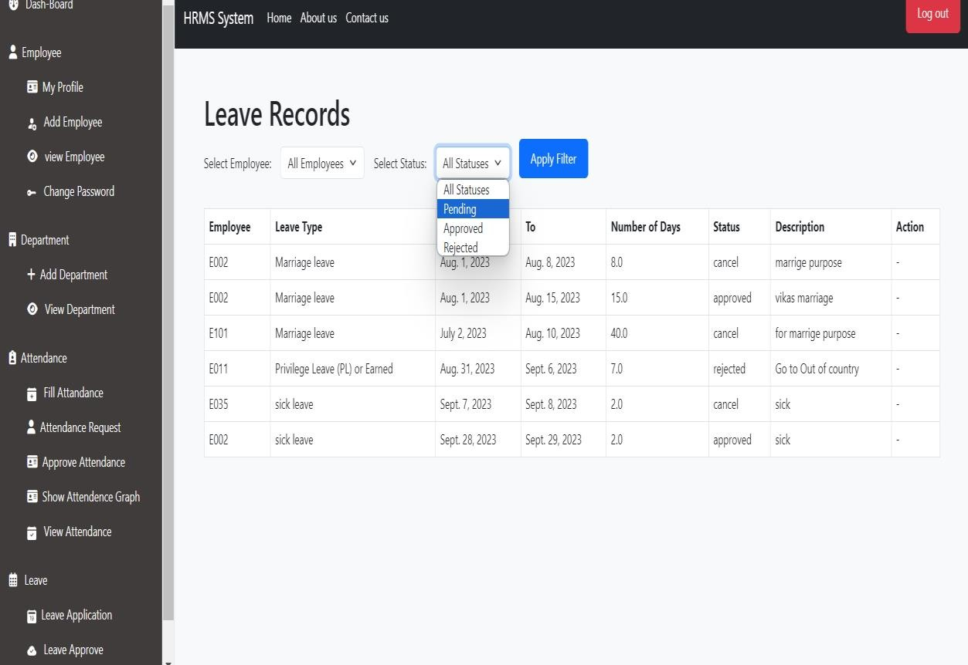

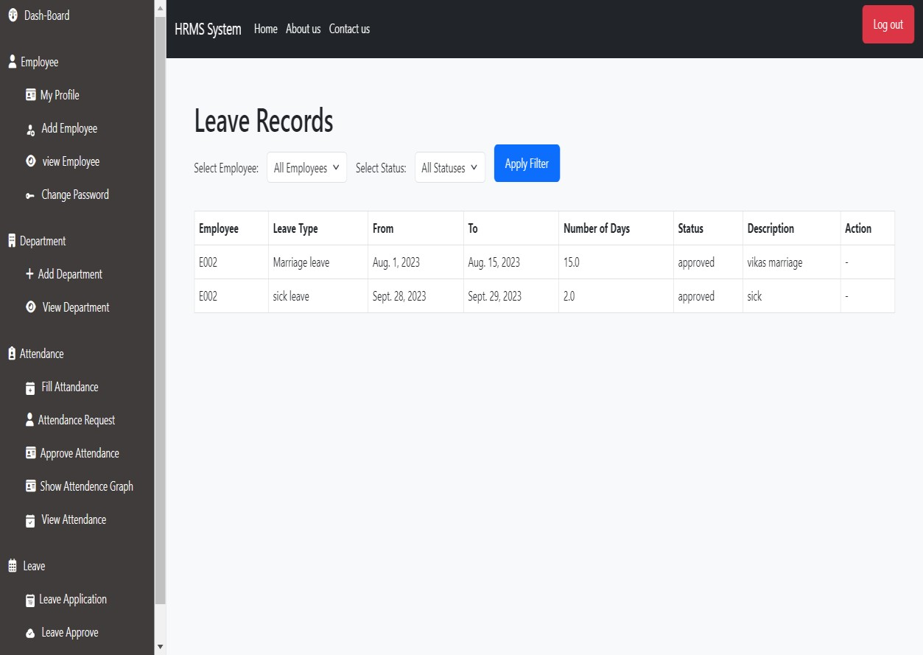

### Security Features

###### User Authentication and Authorization

* 1. Users are required to register and create accounts with securepasswords.
  2. Employee roles are defined (bidder and auctioneer) to control access andpermissions.
  3. HR have additional privileges for system management.

###### Data Encryption and Privacy:

* 1. User data is encrypted to ensure confidentiality.
  2. Sensitive information, such as passwords and is securelystored and transmitted.

###### Access Control:

* 1. Access to sensitive features and data is restricted based on user roles.
  2. Authorization mechanisms prevent unauthorized actions within the system.

###### User Training and Support:

c. User training and support resources are provided to ensure secure usage and prevent common security pitfalls.

###### Data Validation and Sanitization:

* 1. Input data is validated and sanitized to prevent injection attacks and data manipulation.

###### Regular Security Audits:

b. The system undergoes regular security audits and vulnerability assessments to identify and address potential risks.

###### Data Segregation**:**

* 1. Segregate employee data based on access rights to limit exposure of sensitive information to unauthorized users.

###### Data Backup and Recovery:

* 1. Regularly back up HRMS data and maintain a disaster recovery plan to ensure data integrity and availability in case of system failures or breaches.

###### Employee Self-Service Portal:

* Implement a secure self-service portal where employees can request leaves, view their leave balances, and track their leave history.
* This portal is protected with strong authentication methods, like username and password, and perhaps two-factor authentication.

### Future Enhancement

1. **Employee Self-Service Portal:**
   * Provide employees with a secure portal where they can update personal information, view pay slips, request leaves, and track attendance.
   * Allow employees to submit leave requests, check their leave balances, and view the status of their requests.
2. **Mobile App Integration:**
   * Develop a mobile app for employees to access their HR information, request leaves, and view attendance data on the go.
3. **Real-Time Attendance Tracking:**
   * Implement a real-time attendance system that captures clock-in and clock-out times, helping HR and managers track employee attendance accurately.
4. **Geolocation and Biometric Integration:**
   * Enhance attendance tracking by integrating geolocation and biometric verification for added security and accuracy.
5. **Automated Leave Calculation:**
   * Develop a system that automatically calculates leave balances based on company policies and relevant parameters like tenure, role, and leave history.
6. **Leave Calendar and Planner:**
   * Provide managers with a visual leave calendar to assist in resource planning and avoiding leave conflicts.
7. **Customizable Leave Policies:**
   * Allow organizations to configure different types of leaves (sick, vacation, unpaid, etc.) with specific rules and approval workflows.
8. **Leave Notifications and Approvals:**
   * Implement email or in-app notifications for leave requests and approvals to streamline the process and improve communication.
9. **Integrate with Payroll:**
   * Integrate leave data with the payroll system to ensure accurate salary calculations and deductions.
10. **Performance Integration:**
    * Link leave records with performance data to analyse if there's a correlation between leaves taken and performance trends.
11. **Analytics and Reporting:**
    * Provide HR managers with visual dashboards and reports to analyse attendance patterns, leave trends, and employee absence rates.
12. **Compliance Tracking:**
    * Create a module that tracks compliance with labour laws, ensuring leave policies adhere to regulations such as FMLA.
13. **Document Management:**
    * Allow employees to upload medical certificates, doctor's notes, or other required documents for leave requests.
14. **Customizable Notifications:**
    * Let employees choose their preferred mode of receiving notifications (email, SMS, app notifications) for leave-related updates.
15. **Employee Well-Being Features:**
    * Incorporate features like wellness programs, stress management resources, or mental health support, highlighting the organization's commitment to employee well-being.
16. **Integration with Training and Development:**
    * Link leave data with training and development modules to track employees' skill enhancement during their time off.
17. **Gamification and Rewards:**
    * Implement gamified elements that reward employees for maintaining good attendance or following leave policies.
18. **Automatic Return-to-Work Notifications:**
    * Send automated reminders to employees returning from leave, ensuring a smooth transition back to work.
19. **Multi-Lingual Support:**
    * If your organization operates in multiple regions, consider providing the interface in different languages.

# Bibliography

**Djnago official website :-**

[Getting started | Django documentation | Django (djangoproject.com)](https://docs.djangoproject.com/en/4.2/intro/)

**Wikipedia :-**

[Django (web framework) - Wikipedia](https://en.wikipedia.org/wiki/Django_(web_framework))